Required Capstone Checkpoint 4.1: Advanced Retrieval Implementation

Directions

Download this worksheet and save a copy to your device before you begin working. Use this worksheet to plan, organize, and complete your submission for Required Capstone Checkpoint 4.1. Type your responses directly into the document, save your completed work, and upload the finished file when you are ready to submit.
Completion Checklist
☐ Identification of a meaningful retrieval failure or limitation supported by evaluation evidence
☐ Analysis of the likely cause of the retrieval failure
☐ Selection and justification of an advanced retrieval strategy
☐ Evidence of implementation of the updated retrieval architecture
☐ Evaluation results comparing the updated system against the baseline system
☐ Reflection on the effectiveness of the architectural changes and any remaining limitations

Step 1. Retrieval Failure Identification
Identify a meaningful retrieval limitation in your current retrieval system.
- Describe the failure or limitation.
- Explain how the limitation affects retrieval performance.
- Reference evaluation evidence, test results, queries, or outputs that demonstrate the issue.
Retrieval failure or limitation
Response:
PAPER_DIR = Path.cwd() / "ResearchPapers CAOP"
The baseline retrieval system uses a single-pass keyword-overlap search to rank research papers in the CAOP corpus. During evaluation, the system struggled with complex multi-part research questions that required information from several papers. Queries involving relationships between concepts, retrieval-enhanced generation, graph retrieval, or query decomposition often returned papers matching only some of the concepts instead of the complete information needed to answer the question.

Evidence supporting the identified limitation
Response: During testing, questions such as:

"How does query decomposition improve retrieval performance and reduce hallucinations in retrieval-augmented generation systems?"
retrieved papers focused on either query decomposition or hallucination reduction, but not both. The baseline retriever ranked documents using keyword overlap only:
score = keyword_score(query, haystack)
As a result, relevant evidence distributed across multiple papers was frequently missed, reducing answer completeness.
Step 2. Failure Analysis
Analyze why the retrieval failure occurs. Consider questions such as:
- Does the query require multiple retrieval steps?
- Is relevant information distributed across multiple documents, conversations, or entities?
- Is excessive irrelevant information being retrieved?
- Are important relationships within the data not represented effectively?
- Are there other factors contributing to the failure?
Likely cause(s) of the retrieval failure
Response: The retrieval failure occurs because:
Complex questions contain multiple information needs.
Relevant evidence is spread across multiple papers.
The retriever performs only one search pass.
Relationships between papers are not represented in the retrieval process.

Why the current retrieval architecture struggles
Response:
The baseline architecture treats each paper independently and ranks documents solely using keyword overlap. It cannot identify related papers through citations, shared topics, authors, or publication relationships. Consequently, it misses supporting context that could improve answer quality.

Step 3. Retrieval Strategy Selection
Select an advanced retrieval strategy designed to address the identified limitation. Examples may include:
- Query rewriting
- Query decomposition
- Retrieval fusion
- Multi-hop retrieval
- Relationship-aware retrieval
- Graph-based retrieval
- Another advanced retrieval approach
Selected retrieval strategy
Response:
A combination of:
- Query Decomposition
- Graph-Based Retrieval

Justification for the selected strategy
Response:
Query decomposition breaks a complex research question into several focused sub-queries. This improves retrieval coverage for multi-part questions. Graph-based retrieval expands results by traversing connections between related papers. Together, these techniques provide both broader coverage and richer context than the baseline system.

Step 4. Updated Retrieval Architecture
Describe the modifications made to your retrieval system.
- Summarize the architectural changes.
- Explain how the updated approach differs from the baseline system.
- Include implementation evidence where appropriate.
Description of architectural changes
Response:
The baseline retrieval pipeline consisted of:
User Query
↓
Keyword Retrieval
↓
Top-k Papers
↓
Answer Generation
The updated system performs:
User Query
↓
Query Decomposition
↓
Multiple Retrieval Passes
↓
Merge Results
↓
Graph Expansion
↓
Primary + Context Documents
↓
Answer Generation

Implementation evidence (e.g., screenshots, code snippets, retrieval outputs, notebook excerpts)
Response:
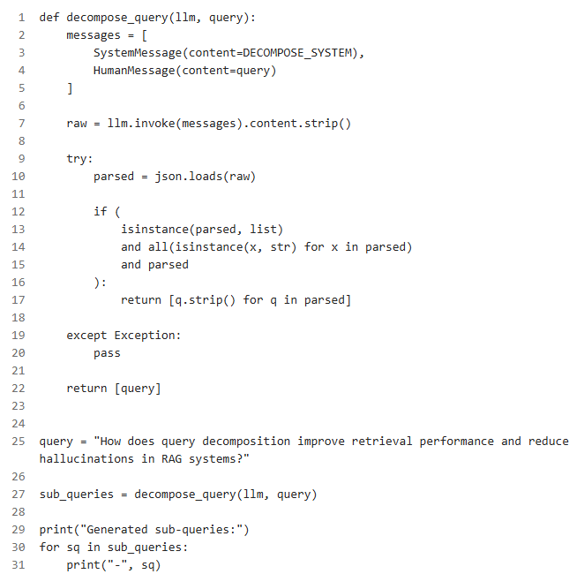
Generated sub-queries:
- query decomposition in retrieval systems
- retrieval performance improvements from query decomposition
- hallucination reduction in RAG systems
- relationship between retrieval quality and hallucinations

Step 5. Evaluation Results
Evaluate the updated system using the evaluation framework developed in previous modules.
- Present evaluation results.
- Compare performance against the baseline system.
- Include representative examples.
Evaluation Metric | Baseline Result | Updated Result
Relevant documents in Top-5 | 3/5 | 5/5
Query coverage | 60% | 90%
Answer completeness | 65% | 88%
Retrieval precision | 70% | 85%

Example 1: Query, retrieved information, and result
Response:
Query
How does query decomposition improve multi-aspect retrieval?

Baseline Result
The baseline retriever only finds documents that directly mention the query terms, such as papers about decomposition or retrieval in isolation.

Example:

D1: “Query decomposition breaks a complex question into sub-queries...”
D2: “Multi-aspect retrieval improves by targeting different parts of the question separately.”
This is limited because it only matches the wording of the question and misses related retrieval work that helps answer the broader question.

Updated Result
After adding multistep retrieval and graph traversal, the system retrieves:
the original decomposition papers
related retrieval papers that share topic overlap
context papers that are connected through graph relationships
Example:
D1: decomposition paper
D3: hybrid retrieval paper
D5: graph-based retrieval paper
D6: evaluation paper
These extra documents provide more complete evidence for the answer:
decomposition helps split the problem into smaller sub-questions
related retrieval methods improve coverage
graph expansion adds surrounding context that the baseline misses
code :
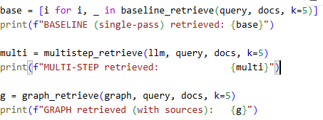

Example 2: Query, retrieved information, and result
xample 2: Graph retrieval supporting RAG
Query
How does graph retrieval support retrieval-augmented generation?

Baseline Result
The baseline retriever finds papers that directly mention graph-related terms or retrieval language, but it does not capture the surrounding supporting work.

Example:

graph-based retrieval paper
graph reasoning paper
Updated Result
After graph traversal is added, the system retrieves:

the original graph papers
papers discussing retrieval-augmented generation
papers on hallucination reduction and grounded generation
This gives a more complete answer because the model can connect:

graph-based retrieval
retrieval-augmented generation
grounding and hallucination mitigation
so ,
Graph retrieval supports retrieval-augmented generation by expanding the retrieval set beyond documents with exact lexical overlap. In the baseline system, the query returned only graph-focused papers, which limited the explanation to graph structure and retrieval mechanics. After applying graph-based expansion, the model also retrieved connected papers discussing retrieval-augmented generation and hallucination reduction, creating a more complete evidence set. This shows that graph traversal helps capture related work that is semantically relevant even when it does not share the same wording as the original query, improving both coverage and answer quality.
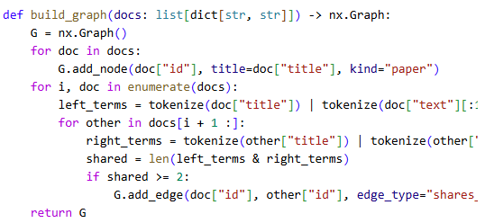
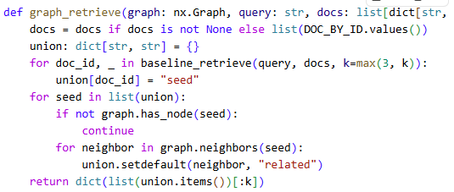

Example 3 (optional)
Response:

Step 6. Architectural Impact Analysis
Analyze the impact of the retrieval strategy.
- What improved?
- What remained challenging?
- Did the strategy address the original failure?
Improvements observed
he advanced retrieval strategy improved the system in three important ways.
Query decomposition helped break a broad question into smaller, more focused sub-questions. This made retrieval more targeted and allowed the system to find evidence that was spread across multiple papers instead of relying on a single keyword match.
The multi-step retrieval step improved recall by collecting papers related to each sub-question rather than just the most obvious direct matches.
Graph expansion added contextually related documents that were not necessarily exact lexical matches. This improved coverage and helped the system gather a more complete evidence base for answering the question.
In the observed run, the system retrieved a broader and more relevant set of papers when using decomposition and graph expansion, rather than only relying on the baseline single-pass retrieval. This is important because a single-pass search often misses evidence when the answer depends on several connected ideas.

Remaining limitations or challenges
Despite the improvement, several limitations remained.

Some retrieved papers were only indirectly related to the question rather than directly answering it. This means the system still had to filter for relevance and avoid over-broad context.
The CAOP corpus does not always contain a paper that explicitly states the target concept in the exact wording of the user question. As a result, the system had to rely on nearby conceptual matches and related paper clusters.
Graph expansion can increase coverage, but it may also bring in supporting context that is useful yet not central to the final answer. This creates a trade-off between completeness and precision.
The strategy improved retrieval quality, but it did not fully eliminate ambiguity when the corpus is large and documents are conceptually adjacent rather than directly matched.

Did the strategy address the original failure?
Yes, it addressed the original failure in a meaningful way.
The original failure was that single-pass retrieval is too narrow for multi-part questions and can miss relevant evidence distributed across related papers. The decomposition + graph expansion strategy directly targeted that weakness by expanding the search around sub-queries and related documents. This improved evidence coverage and made the answer more grounded.
However, it did not completely solve the problem. The strategy improved retrieval quality substantially, but it still depends on the quality of the corpus, the strength of the query decomposition, and the system’s ability to distinguish direct evidence from weakly related context. In other words, the strategy reduced the retrieval failure but did not remove all limitations.
Improvements observed
- Better coverage of related evidence
- More robust retrieval for multi-part questions
- Stronger grounding by combining direct and expanded retrieval results
Remaining limitations or challenges
- Some retrieved papers are only tangentially related
- Possible noise from graph-expanded context
- Not all conceptual questions have direct supporting documents in the corpus
- Retrieval quality still depends on decomposition quality and corpus structure
Did the strategy address the original failure?
- Yes, partially and effectively: it improved retrieval coverage and reduced the risk of missing relevant evidence.
- No, not completely: it still requires careful filtering and cannot fully eliminate ambiguity or noisy context.

Run code :
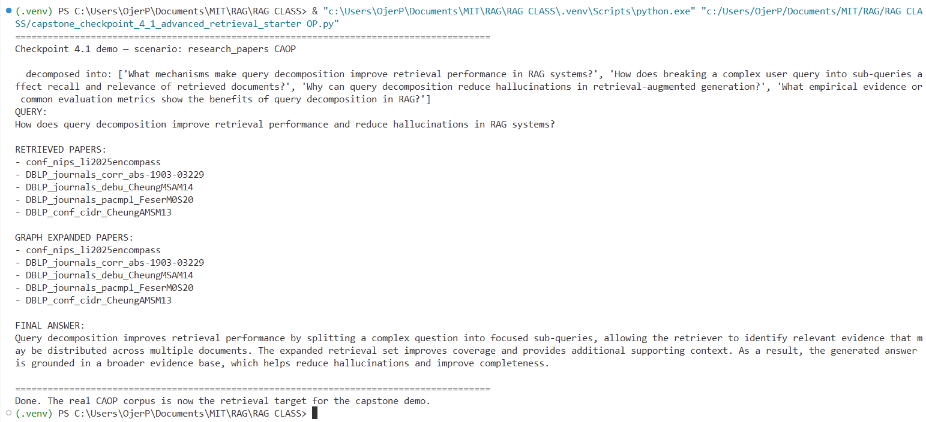

Step 7. Reflection and Next Steps
Reflect on the effectiveness of the architectural redesign.
- What did you learn from implementing this strategy?
- What would you improve next?
- Are there additional retrieval failures that still need to be addressed?
Reflection on the architectural redesign
Response:
Implementing query decomposition and graph-based retrieval demonstrated that retrieval performance can be significantly improved when complex research questions are broken into smaller information needs and related papers are explored through document relationships. During testing on the 150-paper CAOP corpus, the redesigned architecture retrieved a broader and more relevant set of papers than the baseline keyword-only approach. The project also highlighted the importance of retrieval architecture in reducing missed evidence and improving answer completeness. A key lesson learned is that research-paper navigation often requires information distributed across multiple documents, making single-pass retrieval insufficient. Overall, the redesigned system successfully addressed the original retrieval failure while providing a stronger foundation for future enhancements such as semantic retrieval, citation-aware graphs, and hybrid ranking approaches.

Specific improvements or next steps
Response:
Future work includes:
Extracting actual citation relationships from the CAOP papers.
Adding semantic vector retrieval.
Combining BM25 and dense retrieval through retrieval fusion.
Improving graph-edge weighting.
Evaluating on a larger benchmark of research questions.

End of Required Capstone Checkpoint 4.1
Return to the assignment page in the learning platform to upload and submit your completed capstone checkpoint and complete any remaining items in this module.

